Charnwood Country Residence Newsletter
March 2022
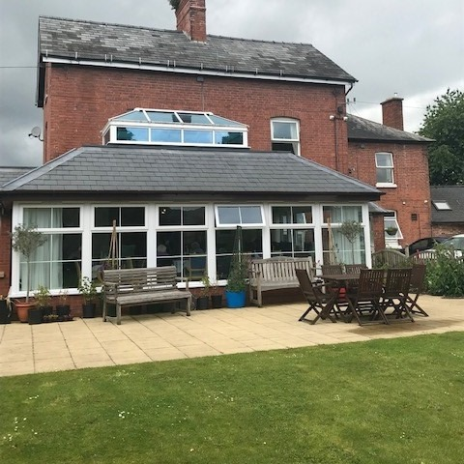
Much Dewchurch, Hereford HR2 8DL
Tel :- 01981540291

OUR FLOWERS ARE LIKE OUR RESIDENTS
THEY BRING COLOUR TO OUR HOME

Welcome to the next edition of our newsletter. This a great way to share up to date news and some of the meaningful ways we spend our time. We hope that you will enjoy receiving this and any feedback, or suggestions on content is always gratefully received. Email b.powell@herefordshirecarehomes.com

Join us on our Facebook Group for day to day updates on the activities we take part in and other aspects of our daily living
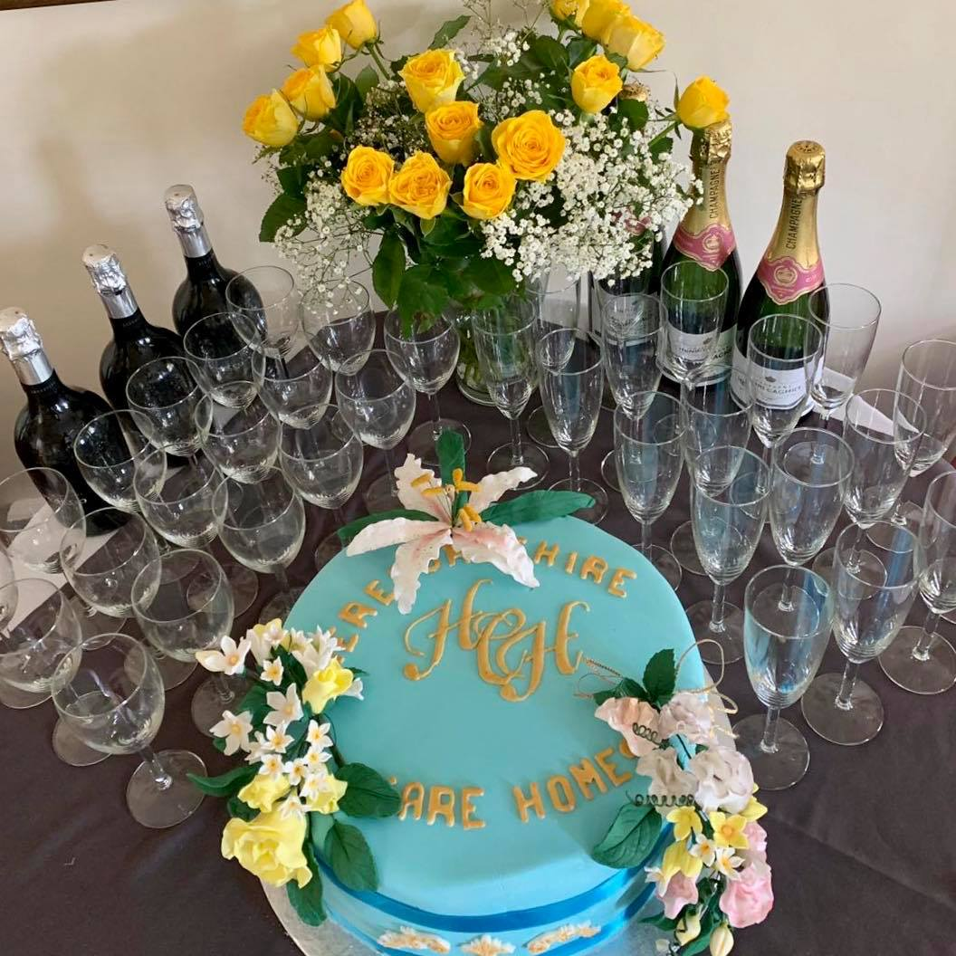
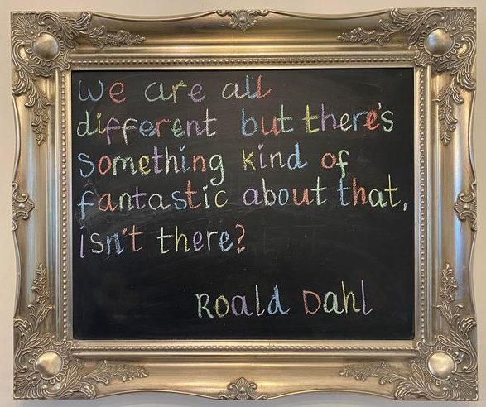

February has been an exceptionally busy month for us all, here at Charnwood. We began our month with Dignity Action Day, which was featured in our previous edition. We also celebrated Valentine’s Day, World Cancer Day and Equality & Diversity Month, in true Charnwood style. Along with regular village walks, and daily in house activities there has been plenty to keep us occupied….
Let’s take a look at our month gone by ….

We have began receiving a weekly floral delivery, which is taken and arranged with a different resident each time. We talk about the different variety of flowers we have received, and use this time as special, quality one to one time, which can be especially important for those who might not be able to join in with our social activities
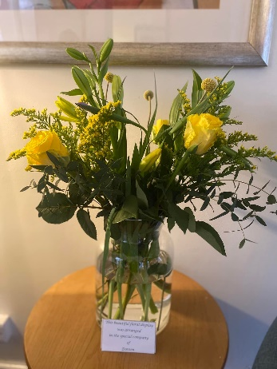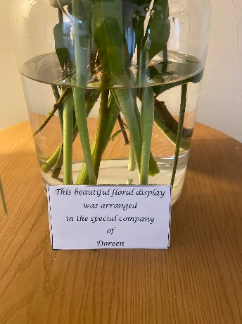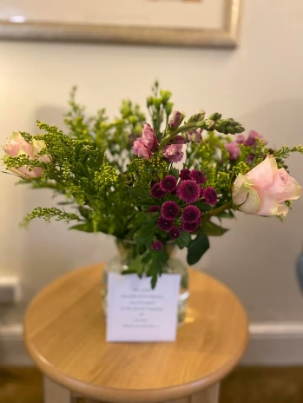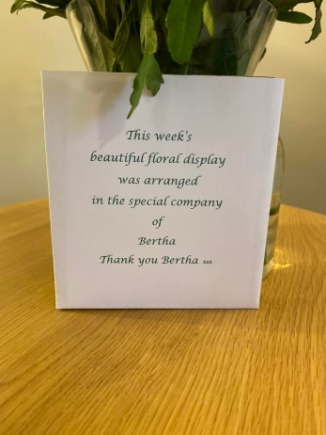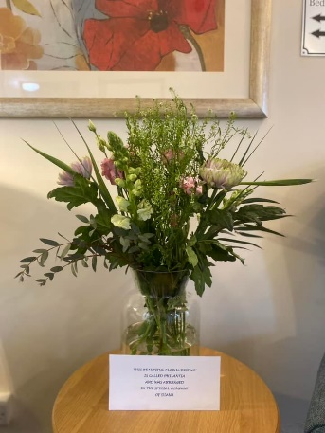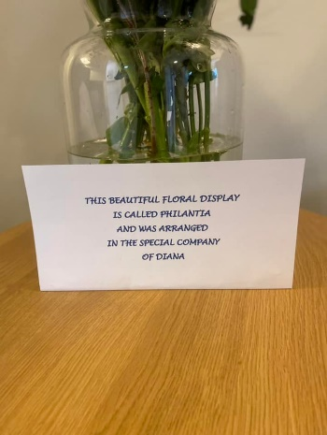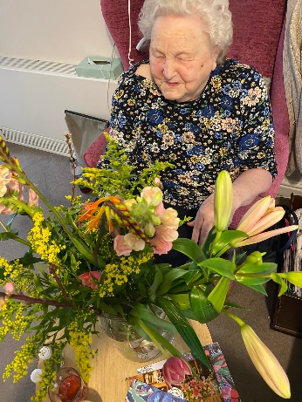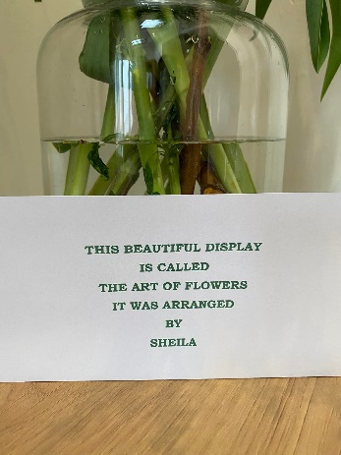
We have created a special reading corner. It has become very popular with our residents…
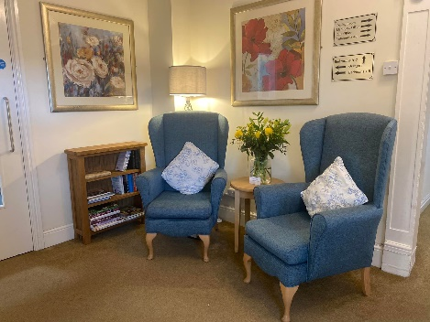
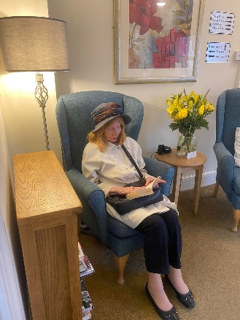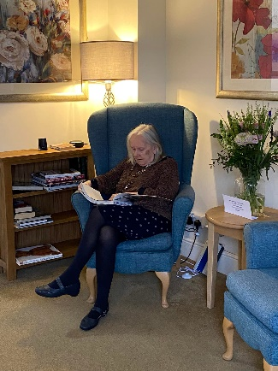

We ensure that everyone feels special every day at Charnwood, and Valentine’s Day was certainly no exception. All of our special residents were presented with a single red rose, a Valentine’s Card from a secret admirer and some chocolates. They sat down to a special Valentine’s lunch and enjoyed a delicious slice of chocolate heart cake. We all took part in a romantic photo shoot, which was then added to a special Valentine’s video which can be watched on our Special Facebook page.

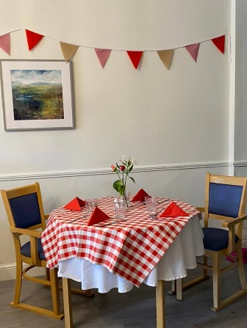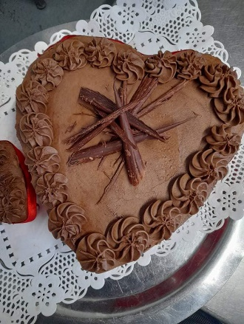

Equality and Diversity Month gave us the opportunity to not only acknowledge, but create an event in which we could celebrate everyone’s uniqueness, in all its’ shapes and forms. We done this in a super fun way, by holding a Mad Hatter’s Tea Party! Team and residents got together to help decorate our dining room for the occasion and took pride in the outcome! It truly was a team effort! Our amazing kitchen team served jam tarts, and heart shaped cakes, and we didn’t just drink tea, there was a fruit punch or Pimms cocktail to choose from as well.

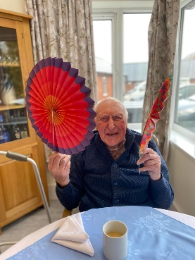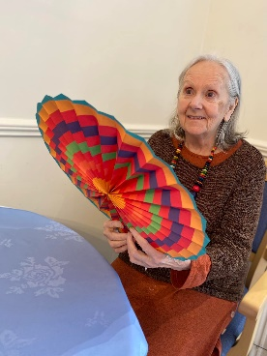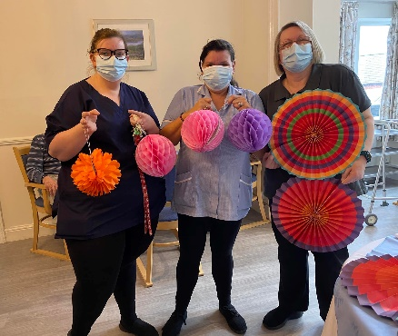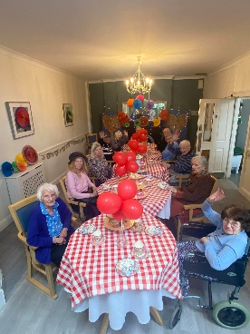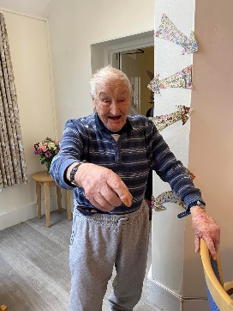
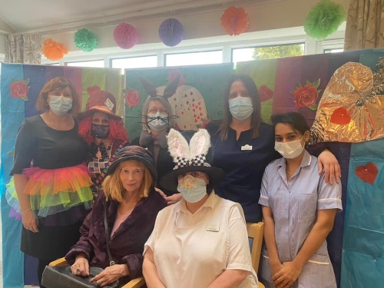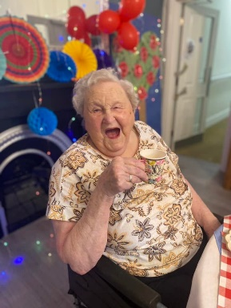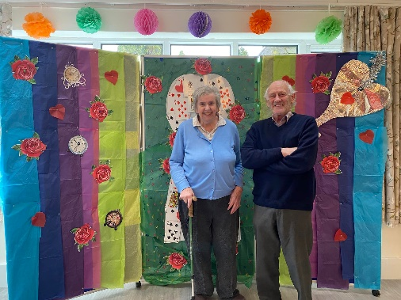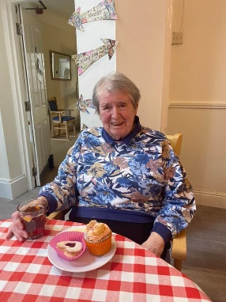
Our ladies and gents have been feeling very pampered recently after their visits to our Salon. Nothing is too much trouble for Theresa, our new hairdresser. We all look forward to her Wednesday visits!
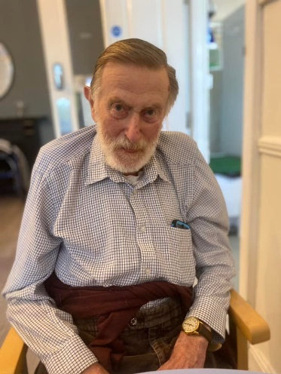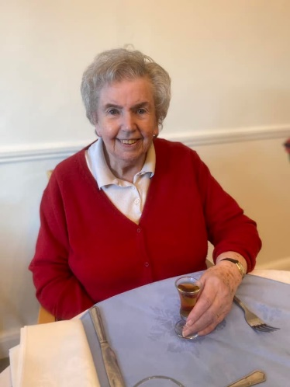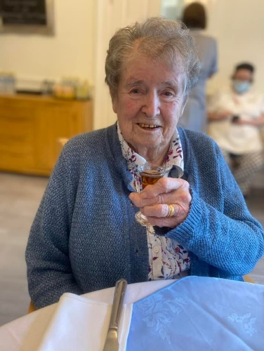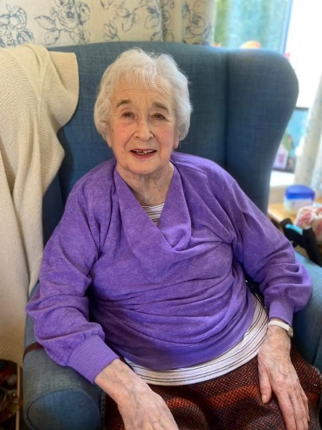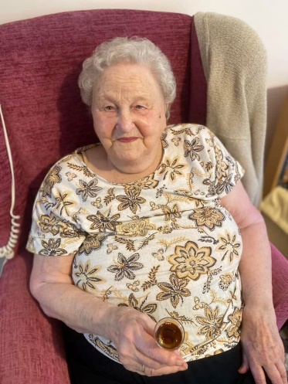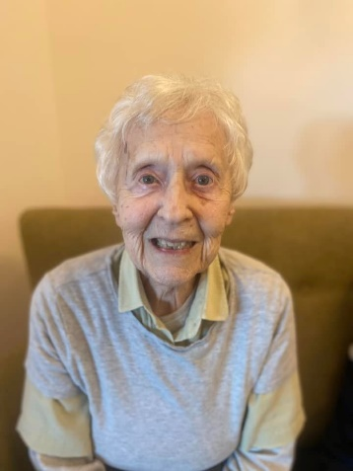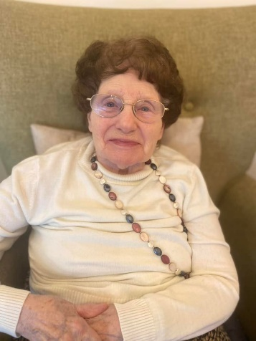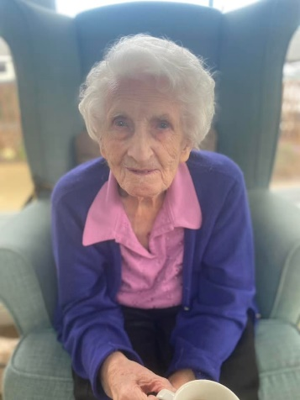

Up and coming events…
St David’s Day 1st March
Nutrition and Hyrdration week 14th-20th March
St Patrick’s Day 17th March
Mother’s Day 26th March
Also..
Our Monthly Resident’s Meeting, many more arts and crafts opportunities, Sing a longs, ball games and village walks. Weekly exercise, poetry mornings, praise services, quizzes, reminiscence, flower arranging and bingo sessions.

